**CSE370 : Database Systems**

**Assignment 02| Spring 2025**

**ID : 22301518 | Name : Adittya Kumar Chowdhury**

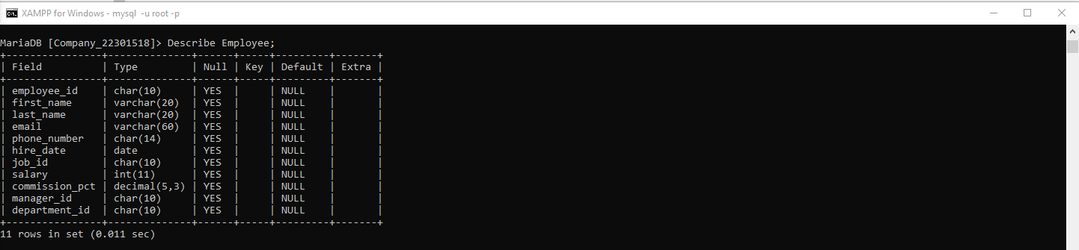

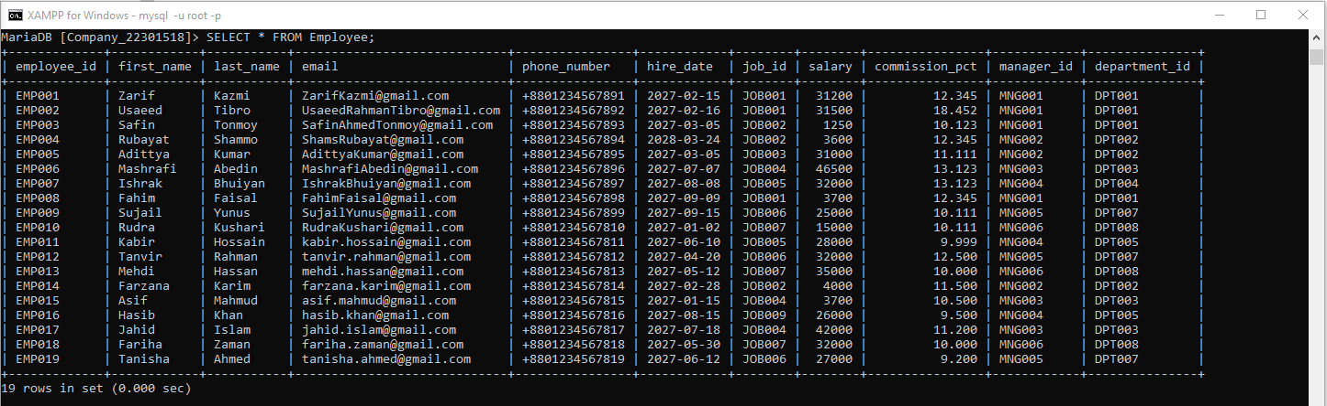

|  |  |
| --- | --- |
| **No 1 Query**  **(as Plain Text)** | SELECT first_name, last_name, email, phone_number, hire_date, department_id FROM Employee WHERE hire_date = (SELECT MAX(hire_date) FROM Employee); |
| **No 1 SS**  **(of Query & Output**  **in Shell)** |  |
|  | |
| **No 2 Query**  **(as Plain Text)** | SELECT first_name, last_name, employee_id, phone_number, salary, department_id FROM Employee e1 WHERE salary=(SELECT MIN(salary) FROM Employee e2 WHERE e1.department_id=e2.department_id); |
| **No 2 SS**  **(of Query & Output**  **in Shell)** |  |
|  | |
| **No 3 Query**  **(as Plain Text)** | SELECT first_name,last_name,employee_id,commission_pct,department_id FROM Employee WHERE department_id='DPT007' AND commission_pct<(SELECT MIN(commission_pct) FROM Employee WHERE department_id='DPT005'); |
| **No 3 SS**  **(of Query & Output**  **in Shell)** |  |
|  | |
| **No 4 Query**  **(as Plain Text)** | SELECT department_id, COUNT(*) AS total_employees FROM Employee WHERE department_id NOT IN (SELECT DISTINCT department_id FROM Employee WHERE salary > 30000) GROUP BY department_id; |
| **No 4 SS**  **(of Query & Output**  **in Shell)** |  |
|  | |
| **No 5 Query**  **(as Plain Text)** | SELECT department_id, job_id, commission_pct FROM Employee WHERE commission_pct<(SELECT MAX(commission_pct) FROM Employee AS subquery WHERE subquery.department_id = Employee.department_id); |
| **No 5 SS**  **(of Query & Output**  **in Shell)** |  |
|  | |
| **No 6 Query**  **(as Plain Text)** | SELECT manager_id FROM Employee WHERE manager_id NOT IN(SELECT DISTINCT manager_id FROM Employee WHERE salary<3500); |
| **No 6 SS**  **(of Query & Output**  **in Shell)** |  |
|  | |
| **No 7 Query**  **(as Plain Text)** | SELECT first_name, last_name, employee_id, email, salary, department_id, commission_pct FROM Employee WHERE commission_pct = (SELECT MIN(commission_pct) FROM Employee AS subquery WHERE subquery.manager_id = Employee.manager_id); |
| **No 7 SS**  **(of Query & Output**  **in Shell)** |  |
|  | |